# https://upload.wikimedia.org/wikipedia/en/f/f1/Capital_University%2C_Jharkhand_logo.png

# CAPITAL UNIVERSITY - KODERMA

CIRCUITS AND SYSTEMS ASSIGNMENT

Name : Arshad Nazir

Electrical and Electronics Engineering

1. Define analog, discrete time and digital signals.

Ans: An analog signal is one type of continuous time-varying signals, and these are classified into composite and simple signals. A simple type of analog signal is nothing but a sine wave, and that can’t be decomposed, whereas a composite type analog signal can be decomposed into numerous sine waves. An analog signal can be defined by using amplitude, time period otherwise frequency, & phase. Amplitude streaks the highest height of the signal, frequency streaks the rate at which an analog signal is varying, and phase streaks the signal position with respect to time nothing. An analog signal is not resistant toward the noise, therefore; it faces distortion as well as reduces the transmission quality. The analog signal value range cannot be fixed.

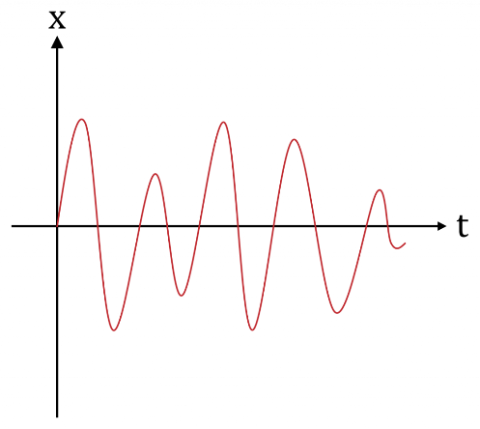

Analog Signal

Similar to analog, digital signals carry the data although it is a bit different. These signals are discrete or not continuous. A digital signal carries the data in the form of binary because it signifies in the bits. These signals can be decomposed into sine waves which are termed as harmonics. Every digital signal has amplitude, frequency, & phase like the analog signal. This signal can be defined by bit interval as well as bit rate. Here, bit interval in nothing but the required time for transmitting an only bit, whereas the bit rate is bit interval frequency.

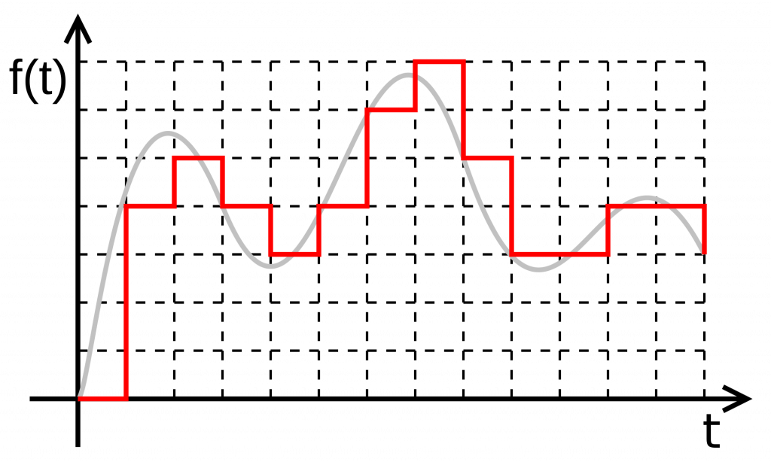Digital Signal

Digital signals are more resistant toward the noise;

Discrete-time systems are signals **for which both the input and the output are discrete-time signals**.

2.What are some of the advantages digital systems compared to analog systems?

* Ans: Digital signals can convey information with less noise, distortion, and interference.
* Digital circuits can be reproduced easily in mass quantities at comparatively low costs.
* Digital signal processing is more flexible because DSP operations can be altered using digitally programmable systems.
* Digital signal processing is more secure because digital information can be easily encrypted and compressed.
* Digital systems are more accurate, and the probability of error occurrence can be reduced by employing error detection and correction codes.
* Digital signals can be easily stored on any magnetic media or optical media using semiconductor chips.
* Digital signals can be transmitted over long distances.

3. Explain the difference between positive logic and negative logic.

Ans: “When a **circuit requires logic 1 to operate**, engineers may refer to this condition as positive logic. Thus, the more positive voltage causes the action to take place. On the other hand, if a circuit requires a logic 0 to cause action, this type circuit is referred to as negative logic.

4. What are universal gates? Why are they called so?

Ans: N AND universal logic gate: It is the combination of NOT and AND gate in such a way that output of NAND gate is connected to the input of the NOT gate. Note: NAND and NOR gates are called universal gates **because they perform all the Logic functions OR, AND and NOT.**

17. Explain the Master-Slave operation of a flip flop.

Ans: Explanation

The master-slave flip flop is constructed by combining two [JK flip flops](https://www.javatpoint.com/jk-flip-flop-in-digital-electronics). These flip flops are connected in a series configuration. In these two flip flops, the 1st flip flop work as "master", called the master flip flop, and the 2nd work as a "slave", called slave flip flop. The master-slave flip flop is designed in such a way that the output of the "master" flip flop is passed to both the inputs of the "slave" [flip flop](https://www.javatpoint.com/basics-of-flip-flop-in-digital-electronics). The output of the "slave" flip flop is passed to inputs of the master flip flop.

In "master-slave flip flop", apart from these two flip flops, an inverter or [NOT gate](https://www.javatpoint.com/note-gate-in-digital-electronics) is also used. For passing the inverted clock pulse to the "slave" flip flop, the inverter is connected to the clock's pulse. In simple words, when CP set to false for "master", then CP is set to true for "slave", and when CP set to true for "master", then CP is set to false for "slave".

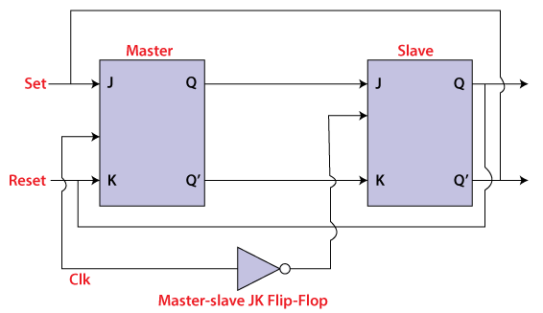

Working:

* When the clock pulse is true, the slave flip flop will be in the isolated state, and the system's state may be affected by the J and K inputs. The "slave" remains isolated until the CP is 1. When the CP set to 0, the master flip-flop passes the information to the slave flip flop to obtain the output.
* The master flip flop responds first from the slave because the master flip flop is the positive level trigger, and the slave flip flop is the negative level trigger.
* The output Q'=1 of the master flip flop is passed to the slave flip flop as an input K when the input J set to 0 and K set to 1. The clock forces the slave flip flop to work as reset, and then the slave copies the master flip flop.
* When J=1, and K=0, the output Q=1 is passed to the J input of the slave. The clock's negative transition sets the slave and copies the master.
* The master flip flop toggles on the clock's positive transition when the inputs J and K set to 1. At that time, the slave flip flop toggles on the clock's negative transition.
* The flip flop will be disabled, and Q remains unchanged when both the inputs of the JK flip flop set to 0.

Timing Diagram of a Master Flip Flop:

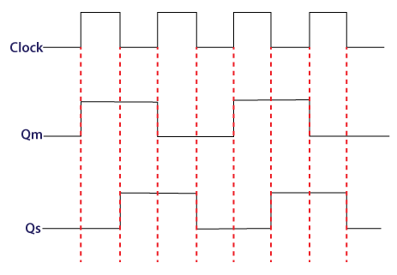

* When the clock pulse set to 1, the output of the master flip flop will be one until the clock input remains 0.
* When the clock pulse becomes high again, then the master's output is 0, which will be set to 1 when the clock becomes one again.
* The master flip flop is operational when the clock pulse is 1. The slave's output remains 0 until the clock is not set to 0 because the slave flip flop is not operational.
* The slave flip flop is operational when the clock pulse is 0. The output of the master remains one until the clock is not set to 0 again.
* Toggling occurs during the entire process because the output changes once in the cycle.

18.Why do we choose Q point at the center of the load line?

Ans: Q point is the DC operating point (Vce,Ic) that we choose on the output characteristics of the transistor.Selecting the Q point means biasing the transistor to that Voltage,Current.

Now selecting the Q point at the centre of the loadline will give you maximum voltage swing on left and right side of the graph and current swing on upside and downside of the graph. So the amplifier or whatever the circuit is can be used for a greater AC voltage range.Hence we select Q point at the centre.

19. Name the two techniques used in the stability of the Q point .explain.

Ans: Stabilization technique: This refers to the use of resistive biasing circuit which allows IB to vary so as to keep IC relatively constant with variations in Ico,β, and VBE. Compensation techniques: This refers to the use of temperature sensitive devices such as thermistors diodes.

20. List out the different types of biasing.

* Ans: Base Bias or Fixed Current Bias. ...
* Base Bias with Emitter Feedback. ...
* Base Bias with Collector Feedback. ...
* Base Bias with Collector and Emitter Feedbacks. ...
* Emitter Bias with Two Supplies. ...
* Voltage Divider Bias. ...
* Input Impedance. ...
* Output Impedance.

21. What do you meant by thermal runway?

Ans: Thermal runaway describes a process that is accelerated by increased temperature, in turn releasing energy that further increases temperature. ... In electrical engineering, thermal runaway is typically associated with increased current flow and power dissipation.

22. Why is the transistor called a current controlled device?

Ans: A bipolar transistor is said to be current controlled because when it is biased in the active region the output (collector) current is controlled from the input (base) current.  
  
A bipolar transistor is said to be in the active region when BE junction is forward biased while CB junction is reverse biased (or vice versa)  
  
In this situation the collector current depends mainly on base current via β (Ic=β\*Ib) and only marginally (second order effect) from collector Voltage (Early effect). Also β depends on Ic.

23. What are the requirements for biasing circuits?

Ans: ·        Emitter base junction must be forward biased and collector base junction must be reverse biased. That means the transistor should be operated in the middle of the active region or Q point should be fixed at the centre of the active region.

·        Circuit design should provide a degree of temperature stability.

·        Q point should be made independent of the transistor parameters such as β.

24. When does a transistor act as a switch?

Ans:  transistor can be used for switching operation for opening or closing of a circuit. This type solid state switching offers significant reliability and lower cost when compared to conventional relays. Both NPN and PNP transistors can be used as switches. Some of the applications use a power transistor as switching device, at that time it may necessary to use another signal level transistor to drive the high-power transistor.

25. What is biasing?

Ans: biasing' usually refers to a fixed DC voltage or current applied to a terminal of an electronic component such as a diode, transistor or vacuum tube in a circuit in which AC signals are also present, in order to establish proper operating conditions for the component.

SECTION B – ANSWER ANY 20 QUESTIONS

26. Define small signal equivalent circuit?

Ans: A small-signal model is an AC equivalent circuit in which the nonlinear circuit elements are replaced by linear elements whose values are given by the first-order (linear) approximation of their characteristic curve near the bias point.

27. Define transconductance?

Ans: **Transconductance** (for **transfer conductance**), also infrequently called **mutual**[**conductance**](https://en.wikipedia.org/wiki/Electrical_conductance), is the electrical characteristic relating the [current](https://en.wikipedia.org/wiki/Electric_current) through the output of a device to the [voltage](https://en.wikipedia.org/wiki/Voltage) across the input of a device. Transconductance is very often denoted as a conductance, *g*m, with a subscript, m, for *mutual*. It is defined as follows:

{\displaystyle g\_{m}={\frac {\Delta I\_{\text{out}}}{\Delta V\_{\text{in}}}}}

For [small signal](https://en.wikipedia.org/wiki/Small_signal) [alternating current](https://en.wikipedia.org/wiki/Alternating_current), the definition is simpler:

{\displaystyle g\_{m}={\frac {i\_{\text{out}}}{v\_{\text{in}}}}}

The [SI](https://en.wikipedia.org/wiki/SI) unit, the **[siemens](https://en.wikipedia.org/wiki/Siemens_(unit)" \o "Siemens (unit))**, with the symbol, **S**; 1 siemens = 1 ampere per volt replaced the old unit of conductance, having the same definition, the *mho* (ohm spelled backwards), symbol, **℧**.

29.Define coupling capacitor?

Ans: A **capacitor that is used to connect the AC signal of one circuit to another circuit** is known as a coupling capacitor. ... On the o/p end, we get the AC signal. So a coupling capacitor is placed between two circuits so that AC signals supplies while the DC signal is blocked.

30. Define input resistance

Ans: The input resistance is the resistance seen by the current source or voltage source which drives the circuit.

31. Define power amplifier

Ans: A power amplifier is an electronic amplifier designed to increase the magnitude of power of a given input signal. The power of the input signal is increased to a level high enough to drive loads of output devices like speakers, hea32. dphones, RF transmitters etc.

32. State Miller’s Theorem

|  |
| --- |
| The Miller’s theorem establishes that in a linear circuit, if there exists a branch with impedance *Z*, connecting two nodes with nodal voltages ­*V1*and *V2*, we can replace this branch by two branches connecting the corresponding nodes to ground by impedances respectively *Z* / (1-*K*) and *KZ* / (*K*-1), where *K* = *V2* / *V1*. |

|  |  |
| --- | --- |
|  | https://paginas.fe.up.pt/~fff/eBook/Imagens/fig_mil_01.gif |

.

33. What are the techniques used to improve input impedance.

Ans: **Techniques of Improving Input Impedance**

Among three configurations (CB, CC and CE), common collector or emitter follower circuit has high input impedance. Typically it is 200 KΩ to 300 KΩ. A single stage emitter follower circuit can give input impedance upto 500 KΩ. However, the input impedance considering biasing resistors is

Figure shows the direct coupling of two stages of emitter follower significantly less. Because Ri’ = R1ll R2llRi The input impedance of the circuit can be improved by direct coupling of two stages of emitter follower amplifier. The input impedance can be increased using two techniques :

•      Using direct coupling (Darlington connection)

•      Using Bootstrap technique

**1. Darlington Transistors**

Figure shows the direct coupling of two stages of emitter follower amplifier. This cascaded connection of two emitter followers is called the Darlington connection

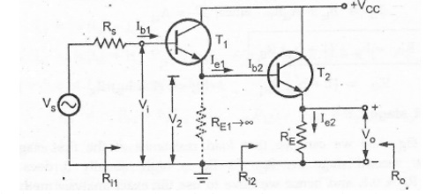

Assume that the load resistance RL is such that RL hoe < 0.1, therefore we can use approximate analysis method for analyzing second stage

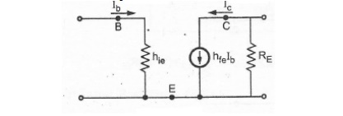

Figure shows approximate h-parameter (AC) equivalent circuit for common emitter configuration. The same circuit can be redrawn by making collector common to have approximate h-parameter equivalent circuit for common collector configuration.

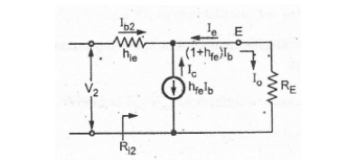

**Analysis of Second stage**:

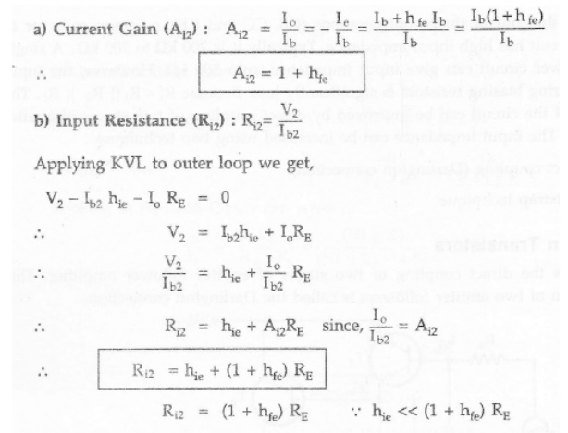

**Analysis of first stage**:

Load resistance of the first stage is the input resistance of the second stage i.e. Ri2. As Ri2 is high, usually it does not meet the requirement hoe Ri2< 0.1, and hence we have to use the exact analysis method for analysis of the first stage.

Figure shows the h-parameter equivalent circuit for common emitter configuration.

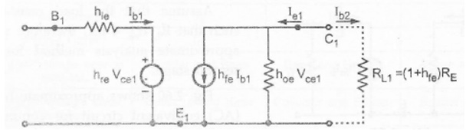

The same circuit can be redrawn by making collector common to have h-parameter equivalent circuit for common collector for configuration.

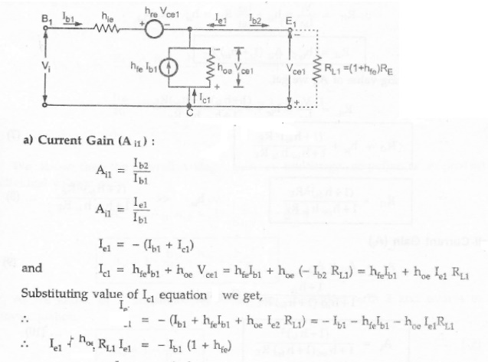

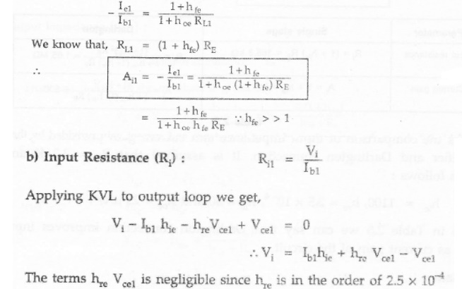

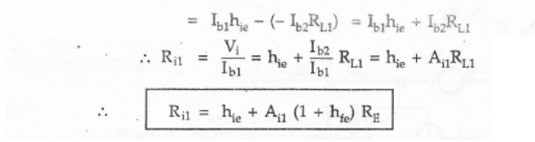

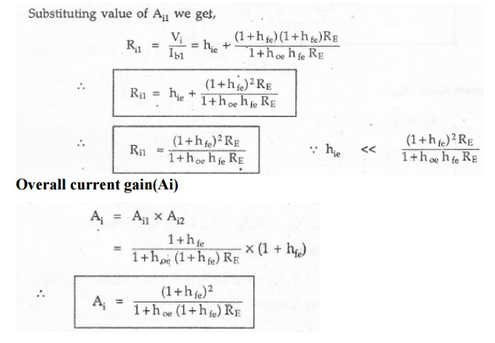

From table, we can say that Darlington connection improves input impedance as well as current gain of the circuit

**Overall Voltage gain**

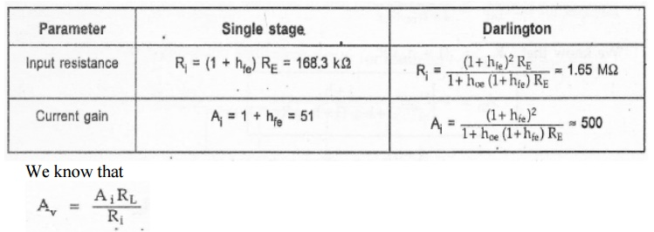

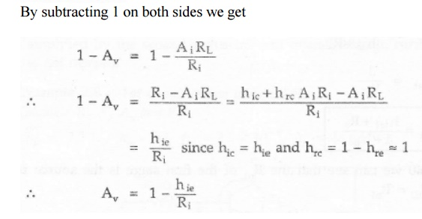

We know that the overall voltage gain in multistage amplifier is a product of individual voltage gain

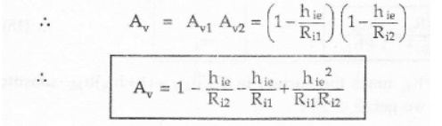

As we know, input resistance Ri1 >> Ri2 we can neglect term 3 and term 4 in the above equation.

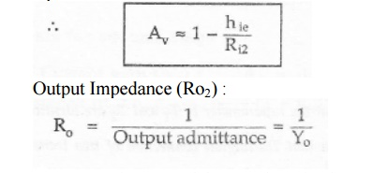

From equation, Yo of the transistor is given as

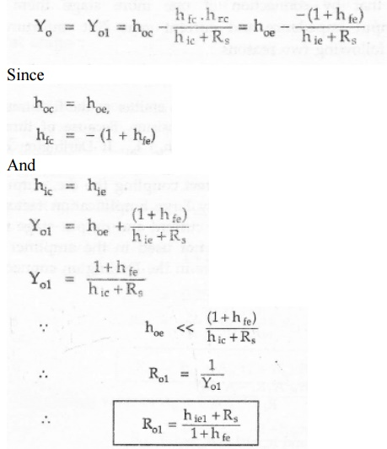

Looking at Figure we can see that the Ri1 of the first stage is the source resistance for second stage, i.e. RS2= RO1

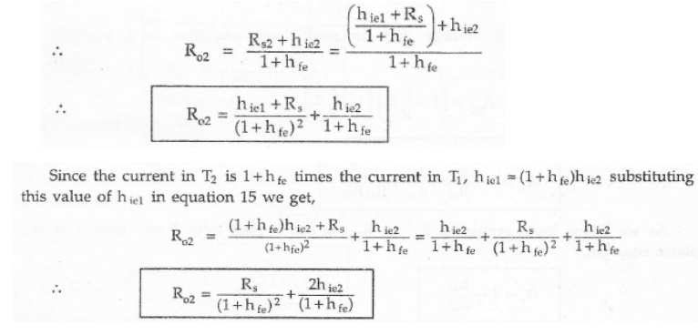

**Key Point:**

In above analysis we have assumed that the h-parameter of T1 and T2 are identical,

From the above analysis we have seen that Darlington connection of two transistor improves current gain and input resistance of the circuit.

**2. Bootstrap Emitter Follower**

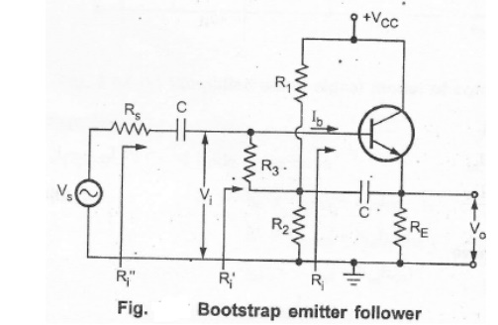

In emitter follower, the input resistance of the amplifier is reduced because of the shunting effect of the biasing resistors. To overcome this problem the emitter follower circuit is modified, as shown in the Figure. Here, two additional components are used, resistance R, and capacitor C .The capacitor, is connected between the emitter and the junction of R1,R2 and R3.

For d.c. signal, capacitor C acts as a open circuit and therefore resistance R1,R2 and R3 provides necessary biasing to keep the transistor in active region.

For ac signal, the capacitor acts as a short circuit. Its value is chosen such that it provides very low reactance nearly short circuit at lowest operating frequency. Hence for ac, the bottom of R3 is effectively connected to the output(the emitter), whereas the top of R3 is at the -input. (the base). In other words, R3 is connected between input node and output node. For such connection effective input resistance is given by Miller's theorem. The two components are

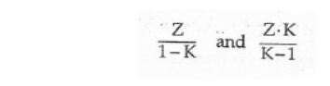

R3 is the impedance between output voltage and input voltage and K is the voltage gain.

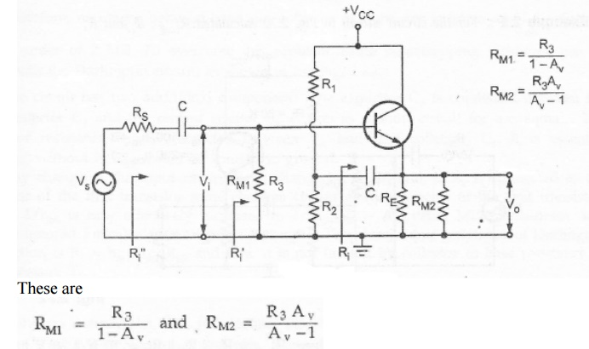

Since, for an emitter follower, Av, approaches unity, then RM2 becomes extremely large.

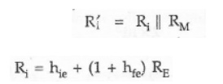

The above effect, when Av tends to unity is called bootstrapping. The name arises from the fact that, if one end of the resistor R3 changes in voltage, the other end of R3 moves through the same potential difference; it is as if R3 is pulling itself up by its bootstraps.

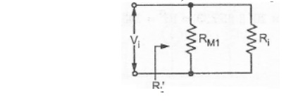

The effective load on the emitter follower can be given as

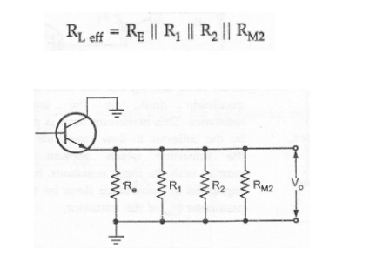

Because of the capacitor, biasing resistances R1 and R2, come on output side shunting effective load resistance. The resistance RM2 is very large and hence it is often neglected.

https://img.brainkart.com/imagebk14/E7FDV0C.jpg

**Problem**

1. For the circuit shown in Figure calculate RLeff ,Ri, and Ri’

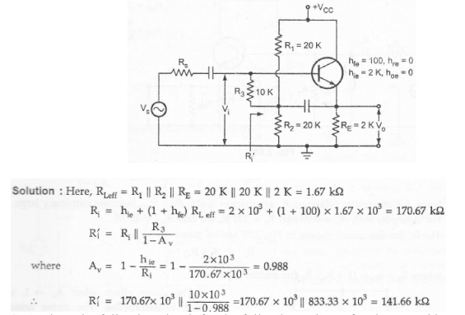

2. Analyze the following circuit for the following values of resistors and h-parameters

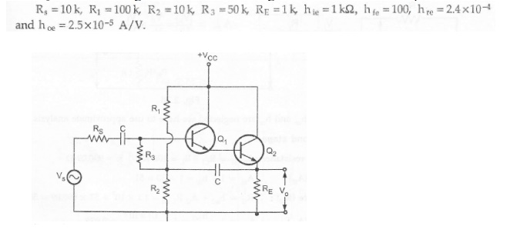

**Solution**

Analysis of second stage

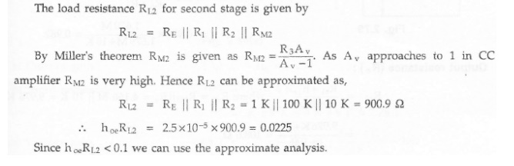

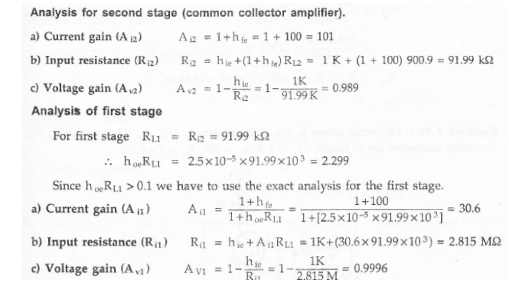

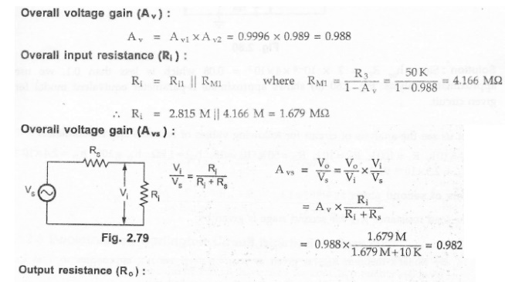

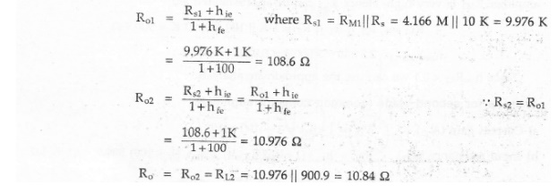

**Multistage Amplifiers**

In practice, we need amplifier which can amplify a signal from a very weak source such as a microphone, to a level which is suitable for the operation of another transducer

Such as loudspeaker. This is achieved by cascading number of amplifier stages, known as multistage amplifier

**Need for Cascading**

For faithful amplification amplifier should have desired voltage gain, current gain and it should match its input impedance with the source and output impedance with the load. Many times these primary requirements of the amplifier can not be achieved with single stage amplifier, because of the limitation of the transistor/FET parameters. In such situations more than one amplifier stages are cascaded such that input and output stages provide impedance matching requirements with some amplification and remaining middle stages provide most of the amplification.

We can say that,

·        When the amplification of a single stage amplifier is not sufficient, or,

·        When the input or output impedance is not of the correct magnitude, for a particular application two or more amplifier stages are connected, in cascade. Such amplifier,with two or more stages is also known as multistage amplifier.

Two Stage Cascaded Amplifier

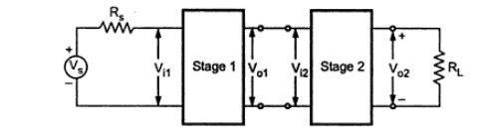

Vi1 is the input of the first stage and Vo2 is the output of second stage.

So,Vo2/Vi1 is the overall voltage gain of two stage amplifier.

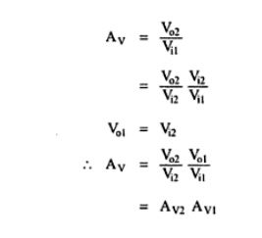

**n-Stage Cascaded Amplifier**

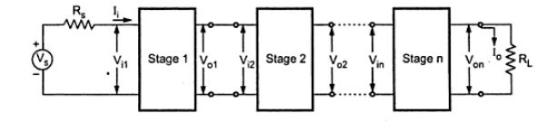

Voltage gain :

The resultant voltage gain of the multistage amplifier is the product of voltage gains of the various stages.

Av = Avl Av2 ... Avn Gain in Decibels

In many situations it is found very convenient to compare two powers on logarithmic scale rather than on a linear scale. The unit of this logarithmic scale is called decibel (abbreviated dB). The number N decibels by which a power P2 exceeds the power P1 is defined by

Decibel, dB denotes power ratio. Negative values of number of dB means that the power P2 is less than the reference power P1 and positive value of number of dB means the power P2 is greater than the reference power P1.

For an amplifier, P1 may represent input power, and P2 may represent output power. Both can be given as

https://img.brainkart.com/imagebk14/XUjlr9p.jpg

Where Ri and Ro are the input and output impedances of the amplifier respectively.Then,

https://img.brainkart.com/imagebk14/hxIh4GA.jpg

If the input and output impedances of the amplifier are equal i.e. Ri = Ro= R, then

https://img.brainkart.com/imagebk14/YhOxj58.jpg

**Gain of Multistage Amplifier in dB**

The gain of a multistage amplifier can be easily calculated if the gain of the individual stages are known in dB, as shown below

20 log10 Av = 20 log10Avl + 20 log10Av2 +…      + 20 log10Avn

Thus, the overall voltage gain in dB of a multistage amplifier is the decibel voltage gains of the individual stages. It can be given as

AvdB = AvldB + Av2dB + ... + AvndB

**Advantages of Representation of Gain in Decibels**

Logarithmic scale is preferred over linear scale to represent voltage and power gains because of the following reasons :

·        In multistage amplifiers, it permits to add individual gains of the stages to calculate overall gain.

·        It allows us to denote, both very small as well as very large quantities of linear, scale by considerably small figures.

·        For example, voltage gain of 0.0000001 can be represented as -140 dB and voltage gain of 1,00,000 can be represented as 100 dB.

·        Many times output of the amplifier is fed to loudspeakers to produce sound which is received by the human ear. It is important to note that the ear responds to the sound intensities on a proportional or logarithmic scale rather than linear scale. Thus use of dB unit is more appropriate for representation of amplifier gains.

Methods of coupling Multistage Amplifiers

In multistage amplifier, the output signal of preceding stage is to be coupled to the input circuit of succeeding stage. For this interstage coupling, different types of coupling

elements can be employed. These are :

1. RC coupling   2 Transformer coupling  3. Direct coupling

**RC coupling**

Figure shows RC coupled amplifier using transistors. The output signal of first stage is coupled to the input of the next stage through coupling capacitor and resistive load at the output terminal of first stage

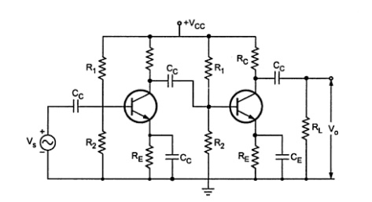

The coupling does not affect the quiescent point of the next stage since the coupling capacitor Cc blocks the d.c. voltage of the first stage from reaching the base of the second stage. The RC network is broadband in nature. Therefore, it gives a wideband frequency response without peak at any frequency and hence used to cover a complete A.F amplifier bands. However its frequency response drops off at very low frequencies due to coupling capacitors and also at high frequencies due to shunt capacitors such as stray capacitance.

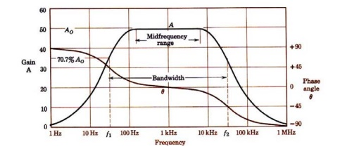

**Transformer Coupling**

Figure shows transformer coupled amplifier using transistors. The output signal of first stage is coupled to the input of the next stage through an impedance matching transformer

This type of coupl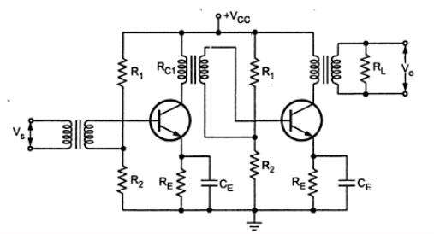ing is used to match the impedance between output and input cascaded stage. Usually, it is used to match the larger output resistance of AF power amplifier to a low impedance load like loudspeaker. As we know, transformer blocks d.c, providing d.c. isolation between the two stages. Therefore, transformer coupling does not affect the quiescent point of the next stage. Frequency response of transformer coupled amplifier is poor in comparison with that an RC coupled amplifier. Its leakage inductance and inter winding capacitances does not allow amplifier to amplify the signals of different frequencies equally well. Inter winding capacitance of the transformer coupled may give rise resonance at certain frequency which makes amplifier to give very high gain at that frequency. By putting shunting capacitors across each winding of the transformer, we can get resonance at any desired RF frequency. Such amplifiers are called tuned voltage amplifiers. These provide high gain at the desired of frequency, i.e. they amplify selective frequencies. For this reason, the transformer-coupled amplifiers are used in radio and TV receivers for amplifying RF signals. As d.c. resistance of the transformer winding is very low, almost all d.c. voltage applied by Vcc is available at the collector. Due to the absence of collector resistance it eliminates unnecessary power loss in the resistor.

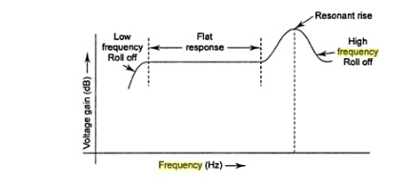

**Direct Coupling**

Figure shows direct coupled amplifier using transistors. The output signal of first stage is directly connected to the input of the next stage. This direct coupling allows the quiescent d.c. collector current of first stage to pass through base of the next stage, affecting its biasing conditions

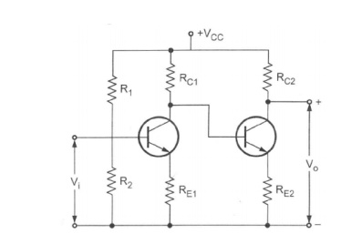

Due to absence of RC components, frequency response is good but at higher frequencies shunting capacitors such as stray capacitances reduce gain of the amplifier.

The transistor parameters such as VBE and β change with temperature causing the collector current and voltage to change. Because of direct coupling these changes appear at the base of next stage, and hence in the output. Such an unwanted change in the output is called drift and it is serious problem in the direct coupled amplifiers.

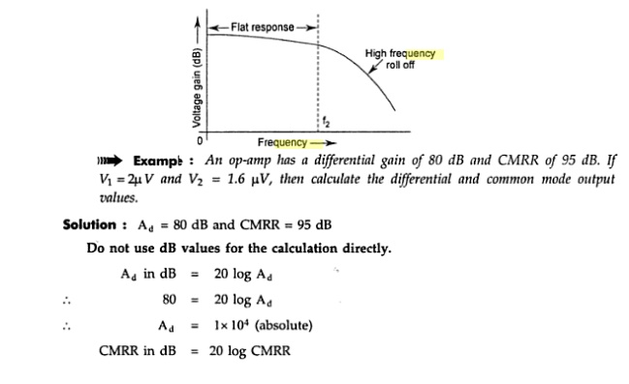

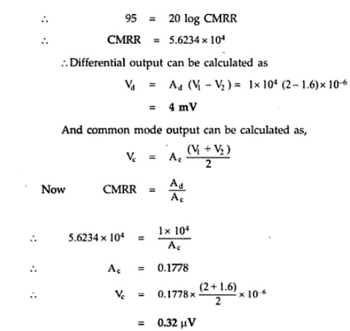

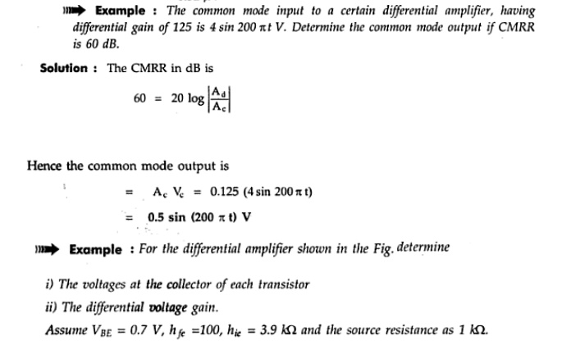

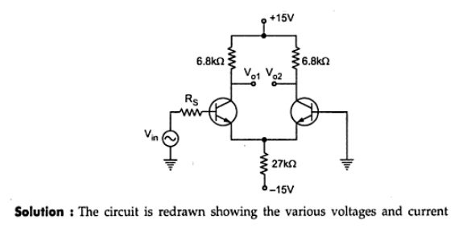

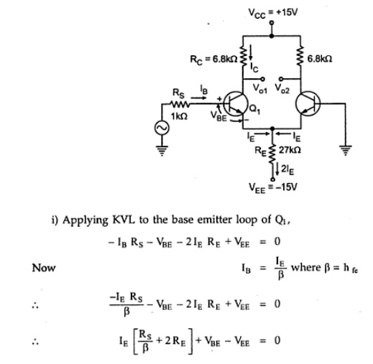

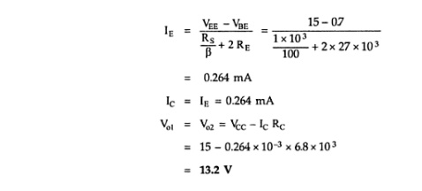

36. Features of differential amplifier.

Ans:

* Differential voltage gain is high.
* Common mode gain is low.
* CMRR (common mode rejection ratio) is high.
* Input impedance is high.
* Wide bandwidth.
* Low offset voltages and currents.
* Output impedance is low.

37. What is meant by CMRR of a differential amplifier?

Ans: CMRR is defined as **the ratio of the differential gain to the common mode gain**, that is CMRR=AD/ACM. ... Explanation: Generally, the CMRR value is very large and usually specified in decibels (db). Also, the CMRR value can establish relationship with common mode output voltage.

38. Define active load

Ans: In circuit design, an active load is a circuit component made up of active devices, such as transistors, intended to present a **high small-signal impedance yet not requiring** a large DC voltage drop, as would occur if a large resistor were used instead. An **active load** or **dynamic load** is a [component](https://en.wikipedia.org/wiki/Electronic_component) or a [circuit](https://en.wikipedia.org/wiki/Electronic_circuit) that functions as a current-stable nonlinear [resistor](https://en.wikipedia.org/wiki/Resistor).

39. What is the Bandwidth of an amplifier?

### Ans:

[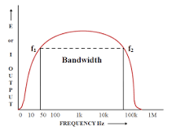](https://www.google.com/search?q=What+is+the+bandwidth+of+an+amplifier?&sxsrf=AOaemvLQ6d1N1c4ssViM8ZLQWz69-KFBHA:1636965012885&tbm=isch&source=iu&ictx=1&fir=2bpCL7_ZB8kihM%2CskgMCZaDWtNzEM%2C_&vet=1&usg=AI4_-kTEPmH8CmpUKSbGUkVPtGBOCGcUjA&sa=X&ved=2ahUKEwjVtOjw-Zn0AhUN4jgGHYK0AzYQ9QF6BAgSEAE#imgrc=2bpCL7_ZB8kihM)

The Bandwidth (BW) of an amplifier is defined as **the difference between the frequency limits of the amplifier**. ... The width of frequencies or the band of frequencies that an amplifier can amplify most effectively is represented using a bandwidth.

40. What is the Pole Zero Compensation technique?

Ans: [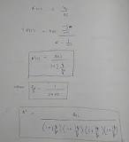](https://www.google.com/search?q=What+is+pole+zero+compensation+technique?&sxsrf=AOaemvJZcCVbvg0QdFsYzXSsKF7UyE7rxw:1636967468613&tbm=isch&source=iu&ictx=1&fir=ysmS9WaLx034-M%2CVBxAfAIINUAiKM%2C_&vet=1&usg=AI4_-kRH49NeXJZ-n_Imc1_mDyC2IxZDpw&sa=X&ved=2ahUKEwiqo-aDg5r0AhVFSX0KHcWyC48Q9QF6BAgNEAE#imgrc=ysmS9WaLx034-M)

It is an external compensation technique and is **used for relatively low closed loop gain**. A pole placed at an appropriate low frequency in the open-loop response reduces the gain of the amplifier to one (0 dB) for a frequency at or just below the location of the next highest frequency pole.

41. Define the Rise time of an amplifier?

Ans Rise time is **the time taken for a signal to cross a specified lower voltage threshold followed by a specified upper voltage threshold**. This is an important parameter in both digital and analog systems.

42. Define Sag in an amplifier?

Ans:

Sag refers to **the drooping of the power supply voltage in response to large transient signals**, which lends a certain dynamic "feel" to the tube amplifier that is not generally found in solid-state amplifiers.

43. Define slew rate?

Ans:

The slew rate is defined as **the maximum rate of change of output Voltage caused by a step input voltage**. An ideal slew rate is infinite which means that op-amp's output voltage should change instantaneously in response to input step voltage.

44. How can the slew rate be made faster?

Ans:

The slew rate of an OTA or op-amp is proportional to the maximum current, usually available from the first stage of the circuit. Increase in the slew rate **requires increase in the value of bias current source**, which will increase the overall power dissipation of the circuit.

45. How high pass RC circuit be used as a differentiator?

Ans:

How can RC circuit be used as differentiator?

[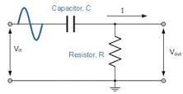](https://www.google.com/search?q=How+can+RC+circuit+be+used+as+differentiator?&sxsrf=AOaemvLwthsA-v5X8L2GNKD_-rFTiWhGLg:1636971352219&tbm=isch&source=iu&ictx=1&fir=HtjpI-QqOAwq3M%2CjvaVxYctHBiBBM%2C_&vet=1&usg=AI4_-kROq7C22PKIu3cHIowi2kHV1HdBhA&sa=X&ved=2ahUKEwi01NK_kZr0AhUGzDgGHWibAxQQ9QF6BAgXEAE#imgrc=HtjpI-QqOAwq3M)

It acts as a differentiator only **when the time constant is too small**. The voltage at output is proportional to the current through the capacitor. The current through the capacitor can be expressed as C dv / dt.

46. How low pass RC circuit be used as a integrator?

Ans: How can a low pass RC circuit be used as an integrator?

[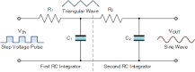](https://www.google.com/search?q=How+can+a+low+pass+RC+circuit+be+used+as+an+integrator?&sxsrf=AOaemvIr7rHqSv-hID6nGAJjr8W9RnMBdA:1636971518377&tbm=isch&source=iu&ictx=1&fir=W-2oSzelvz96PM%2CHMnTJDfOLVrUeM%2C_&vet=1&usg=AI4_-kSZ7_98jTH19WERfBloL8TKhIRMjg&sa=X&ved=2ahUKEwjwnvCOkpr0AhU5zzgGHcRXDlMQ9QF6BAgUEAE#imgrc=W-2oSzelvz96PM)

1. If the input signal is a sine wave, an rc integrator will simply act as a simple low pass filter (LPF) above its cut-off point with the cut-off or corner frequency corresponding to the RC time constant (tau, τ) of the series network. ...
2. Thus the rate of charging or discharging depends on the RC time constant, τ = RC.

48. What are the classifications of a power amplifier?

Ans:

Power amplifier circuits (output stages) are classified as **A, B, AB and C for linear designs**—and class D and E for switching designs. The classes are based on the proportion of each input cycle (conduction angle) during which an amplifying device passes current.

### lass A

[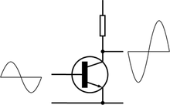](https://en.wikipedia.org/wiki/File:Electronic_Amplifier_Class_A.png)

Class-A amplifier

In a class-A amplifier, 100% of the input signal is used (conduction angle Θ = 360°). The active element remains conducting[[2]](https://en.wikipedia.org/wiki/Power_amplifier_classes" \l "cite_note-2) all of the time.

Amplifying devices operating in class A conduct over the entire range of the input cycle. A *class-A amplifier* is distinguished by the output stage devices being [biased](https://en.wikipedia.org/wiki/Biasing) for class A operation. Subclass A2 is sometimes used to refer to vacuum-tube class-A stages that drive the grid slightly positive on signal peaks for slightly more power than normal class A (A1; where the grid is always negative[[3]](https://en.wikipedia.org/wiki/Power_amplifier_classes" \l "cite_note-3)[[4]](https://en.wikipedia.org/wiki/Power_amplifier_classes#cite_note-:0-4)). This, however, incurs higher signal distortion[*[citation needed](https://en.wikipedia.org/wiki/Wikipedia:Citation_needed" \o "Wikipedia:Citation needed)*].

#### Advantages of class-A amplifiers

* Class-A designs can be simpler than other classes insofar as class -AB and -B designs require two connected devices in the circuit ([push–pull output](https://en.wikipedia.org/wiki/Push%E2%80%93pull_output)), each to handle one half of the waveform whereas class A can use a single device ([single-ended](https://en.wikipedia.org/wiki/Single-ended_signalling)).
* The amplifying element is biased so the device is always conducting, the quiescent (small-signal) collector current (for [transistors](https://en.wikipedia.org/wiki/Transistor); drain current for [FETs](https://en.wikipedia.org/wiki/FET) or anode/plate current for vacuum tubes) is close to the most linear portion of its [transconductance](https://en.wikipedia.org/wiki/Transconductance" \o "Transconductance) curve.
* Because the device is never 'off' there is no "turn on" time, no problems with charge storage, and generally better high frequency performance and feedback loop stability (and usually fewer high-order harmonics).
* The point where the device comes closest to being 'off' is not at 'zero signal', so the problems of [crossover distortion](https://en.wikipedia.org/wiki/Crossover_distortion) associated with class-AB and -B designs is avoided.
* Best for low signal levels of radio receivers due to low distortion.

#### Disadvantage of class-A amplifiers

* Class-A amplifiers are inefficient. A maximum theoretical efficiency of 25% is obtainable using usual configurations, but 50% is the maximum for a transformer or inductively coupled configuration.[[5]](https://en.wikipedia.org/wiki/Power_amplifier_classes#cite_note-5) In a power amplifier, this not only wastes power and limits operation with batteries, but increases operating costs and requires higher-rated output devices. Inefficiency comes from the standing current, which must be roughly half the maximum output current, and a large part of the power supply voltage is present across the output device at low signal levels. If high output power is needed from a class-A circuit, the power supply and accompanying heat becomes significant. For every [watt](https://en.wikipedia.org/wiki/Watt) delivered to the [load](https://en.wikipedia.org/wiki/External_electric_load), the amplifier itself, at best, uses an extra watt. For high power amplifiers this means very large and expensive power supplies and heat sinks.
* Because the output devices are in full operation at all times (unlike a class A/B amplifier), they will not have as long a life unless the amplifier is specifically over-designed to take this into account, adding to the cost of maintaining or designing the amplifier.

Class-A power amplifier designs have largely been superseded by more efficient designs, though their simplicity makes them popular with some hobbyists. There is a market for expensive **high fidelity** class-A amps considered a "cult item" among audiophiles[[6]](https://en.wikipedia.org/wiki/Power_amplifier_classes" \l "cite_note-6) mainly for their absence of [crossover distortion](https://en.wikipedia.org/wiki/Crossover_distortion) and reduced odd-harmonic and high-order harmonic [distortion](https://en.wikipedia.org/wiki/Audio_distortion). Class A power amplifiers are also used in some ["boutique" guitar amplifiers](https://en.wikipedia.org/wiki/Boutique_amplifier) due to their unique tonal quality and for reproducing vintage tones.

#### Single-ended and triode class-A amplifiers

Some hobbyists who prefer class-A amplifiers also prefer the use of thermionic valve (tube) designs instead of transistors, for several reasons:

* Single-ended output stages have an asymmetrical [transfer function](https://en.wikipedia.org/wiki/Transfer_function), meaning that even-order harmonics in the created distortion tend to not cancel out (as they do in [push–pull output](https://en.wikipedia.org/wiki/Push%E2%80%93pull_output) stages). For tubes, or [FETs](https://en.wikipedia.org/wiki/FET), most distortion is second-order harmonics, from the [square law](https://en.wikipedia.org/wiki/Square-law_detector) [transfer characteristic](https://en.wikipedia.org/wiki/Transfer_characteristic), which to some produces a "warmer" and more pleasant sound.[[7]](https://en.wikipedia.org/wiki/Power_amplifier_classes#cite_note-7)[[8]](https://en.wikipedia.org/wiki/Power_amplifier_classes#cite_note-8)
* For those who prefer low distortion figures, the use of tubes with class A (generating little odd-harmonic distortion, as mentioned above) together with symmetrical circuits (such as push–pull output stages, or balanced low-level stages) results in the cancellation of most of the even distortion harmonics, hence the removal of most of the distortion.
* Historically, valve amplifiers were often used as a class-A power amplifier simply because valves are large and expensive; many class-A designs use only a single device.

Transistors are much less expensive than tubes so more elaborate designs that use more parts are still less expensive to manufacture than tube designs. A classic application for a pair of class-A devices is the [long-tailed pair](https://en.wikipedia.org/wiki/Long-tailed_pair), which is exceptionally linear, and forms the basis of many more complex circuits, including many audio amplifiers and almost all [op-amps](https://en.wikipedia.org/wiki/Operational_amplifier).

Class-A amplifiers may be used in output stages of [op-amps](https://en.wikipedia.org/wiki/Operational_amplifier)[[9]](https://en.wikipedia.org/wiki/Power_amplifier_classes#cite_note-9) (although the accuracy of the bias in low cost op-amps such as the **741** may result in class A or class AB or class B performance, varying from device to device or with temperature). They are sometimes used as medium-power, low-efficiency, and high-cost audio power amplifiers. The power consumption is unrelated to the output power. At idle (no input), the power consumption is essentially the same as at high output volume. The result is low efficiency and high heat dissipation.

### Class B

[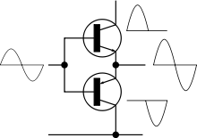](https://en.wikipedia.org/wiki/File:Electronic_Amplifier_Push-pull.svg)

Ideal class-B (push–pull) amplifier. In practice, distortion occurs near the crossover point.

In a class-B amplifier, the active device conducts for 180 degrees of the cycle. This would cause intolerable distortion if there were only one device, so two devices are usually used, especially at audio frequencies. Each conducts for one half (180°) of the signal cycle, and the device currents are combined so that the load current is continuous.[[10]](https://en.wikipedia.org/wiki/Power_amplifier_classes#cite_note-10)

At [radio frequency](https://en.wikipedia.org/wiki/Radio_frequency), if the coupling to the load is via a [tuned circuit](https://en.wikipedia.org/wiki/Tuned_circuit), a single device operating in class B can be used because the stored energy in the tuned circuit supplies the "missing" half of the waveform. Devices operating in Class B are used in linear amplifiers, so called because the radio frequency output power is proportional to the square of the input excitation voltage. This characteristic prevents distortion of amplitude-modulated or frequency-modulated signals passing through the amplifier. Such amplifiers have an efficiency around 60%.[[11]](https://en.wikipedia.org/wiki/Power_amplifier_classes#cite_note-ARRL1991-11)

When Class-B amplifiers amplify the signal with two active devices, each operates over one half of the cycle. Efficiency is much improved over class-A amplifiers.[[12]](https://en.wikipedia.org/wiki/Power_amplifier_classes#cite_note-12) Class-B amplifiers are also favoured in battery-operated devices, such as [transistor radios](https://en.wikipedia.org/wiki/Transistor_radio). Class B has a maximum theoretical efficiency of π/4 (≈ 78.5%).[[13]](https://en.wikipedia.org/wiki/Power_amplifier_classes#cite_note-13)

A practical circuit using class-B elements is the [push–pull stage](https://en.wikipedia.org/wiki/Push%E2%80%93pull_output), such as the very simplified complementary pair arrangement shown at right. Complementary devices are each used for amplifying the opposite halves of the input signal, which is then recombined at the output. This arrangement gives good efficiency, but usually suffers from the drawback that there is a small mismatch in the cross-over region – at the "joins" between the two halves of the signal, as one output device has to take over supplying power exactly as the other finishes. This is called [crossover distortion](https://en.wikipedia.org/wiki/Crossover_distortion). An improvement is to bias the devices so they are not completely off when they are not in use. This approach is called *class AB* operation.[*[citation needed](https://en.wikipedia.org/wiki/Wikipedia:Citation_needed" \o "Wikipedia:Citation needed)*]

### Class AB

[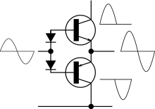](https://en.wikipedia.org/wiki/File:Electronic_Amplifier_Class_AB_Bipolar.svg)

Ideal class-AB amplifier

In a class-AB amplifier, the conduction angle is intermediate between class A and B; each one of the two active elements conducts more than half of the time. Class AB is widely considered a good compromise for amplifiers, since much of the time the music signal is quiet enough that the signal stays in the "class-A" region, where it is amplified with good fidelity, and by definition if passing out of this region, is large enough that the distortion products typical of class B are relatively small. The crossover distortion can be reduced further by using negative feedback.

In class-AB operation, each device operates the same way as in class B over half the waveform, but also conducts a small amount on the other half.[[14]](https://en.wikipedia.org/wiki/Power_amplifier_classes#cite_note-14) As a result, the region where both devices simultaneously are nearly off (the "dead zone") is reduced. The result is that when the waveforms from the two devices are combined, the crossover is greatly minimised or eliminated altogether. The exact choice of **quiescent current** (the standing current through both devices when there is no signal) makes a large difference to the level of [distortion](https://en.wikipedia.org/wiki/Audio_distortion) (and to the risk of [thermal runaway](https://en.wikipedia.org/wiki/Thermal_runaway), which may damage the devices). Often, bias voltage applied to set this quiescent current must be adjusted with the temperature of the output transistors. (For example, in the circuit shown at right, the diodes would be mounted physically close to the output transistors, and specified to have a matched temperature coefficient.) Another approach (often used with thermally tracking bias voltages) is to include small value resistors in series with the emitters.

Class AB sacrifices some efficiency over class B in favor of linearity, thus is less efficient (below 78.5% for full-amplitude [sine waves](https://en.wikipedia.org/wiki/Sinewave) in transistor amplifiers, typically; much less is common in class-AB vacuum-tube amplifiers). It is typically much more efficient than class A.

### Suffix numbers for vacuum tube amplifiers

A vacuum tube amplifier design will sometimes have an additional suffix number for the class, for example, class B1. A suffix 1 indicates that grid current does not flow during any part of the input waveform, where a suffix 2 indicates grid current flows for part of the input waveform. This distinction affects the design of the driver stages for the amplifier. Suffix numbers are not used for semiconductor amplifiers.[[15]](https://en.wikipedia.org/wiki/Power_amplifier_classes#cite_note-15)

### Class C

[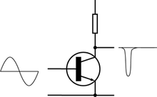](https://en.wikipedia.org/wiki/File:Electronic_Amplifier_Class_C.png)

Class-C amplifier

In a class-C amplifier, less than 50% of the input signal is used (conduction angle Θ < 180°). Distortion is high and practical use requires a tuned circuit as load. Efficiency can reach 80% in radio-frequency applications.[[11]](https://en.wikipedia.org/wiki/Power_amplifier_classes#cite_note-ARRL1991-11)

The usual application for class-C amplifiers is in RF [transmitters](https://en.wikipedia.org/wiki/Transmitter) operating at a single fixed [carrier frequency](https://en.wikipedia.org/wiki/Carrier_frequency), where the distortion is controlled by a tuned load on the amplifier. The input signal is used to switch the active device, causing pulses of current to flow through a [tuned circuit](https://en.wikipedia.org/wiki/LC_circuit) forming part of the load.[[16]](https://en.wikipedia.org/wiki/Power_amplifier_classes#cite_note-16)

The class-C amplifier has two modes of operation: tuned and untuned.[[17]](https://en.wikipedia.org/wiki/Power_amplifier_classes#cite_note-17) The diagram shows a waveform from a simple class-C circuit without the tuned load. This is called untuned operation, and the analysis of the waveforms shows the massive distortion that appears in the signal. When the proper load (e.g., an inductive-capacitive filter plus a load resistor) is used, two things happen. The first is that the output's bias level is clamped with the average output voltage equal to the supply voltage. This is why tuned operation is sometimes called a *clamper*. This restores the waveform to its proper shape, despite the amplifier having only a one-polarity supply. This is directly related to the second phenomenon: the waveform on the center frequency becomes less distorted. The residual distortion is dependent upon the [bandwidth](https://en.wikipedia.org/wiki/Bandwidth_(signal_processing)) of the tuned load, with the center frequency seeing very little distortion, but greater attenuation the farther from the tuned frequency that the signal gets.

The tuned circuit resonates at one frequency, the fixed carrier frequency, and so the unwanted frequencies are suppressed, and the wanted full signal (sine wave) is extracted by the tuned load. The signal bandwidth of the amplifier is limited by the [Q-factor](https://en.wikipedia.org/wiki/Q-factor) of the tuned circuit but this is not a serious limitation. Any residual harmonics can be removed using a further filter.

In practical class-C amplifiers a tuned load is invariably used. In one common arrangement the resistor shown in the circuit above is replaced with a parallel-tuned circuit consisting of an inductor and capacitor in parallel, whose components are chosen to resonate at the frequency of the input signal. Power can be coupled to a load by transformer action with a secondary coil wound on the inductor. The average voltage at the collector is then equal to the supply voltage, and the signal voltage appearing across the tuned circuit varies from near zero to near twice the supply voltage during the RF cycle. The input circuit is biased so that the active element (e.g., transistor) conducts for only a fraction of the RF cycle, usually one third (120 degrees) or less.[[18]](https://en.wikipedia.org/wiki/Power_amplifier_classes#cite_note-ElectronicRadio-18)

The active element conducts only while the collector voltage is passing through its minimum. By this means, power dissipation in the active device is minimised, and efficiency increased. Ideally, the active element would pass only an instantaneous current pulse while the voltage across it is zero: it then dissipates no power and 100% efficiency is achieved. However practical devices have a limit to the peak current they can pass, and the pulse must therefore be widened, to around 120 degrees, to obtain a reasonable amount of power, and the efficiency is then 60–70%.[[18]](https://en.wikipedia.org/wiki/Power_amplifier_classes#cite_note-ElectronicRadio-18)

### Class D

*Main article:*[*Class-D amplifier*](https://en.wikipedia.org/wiki/Class-D_amplifier)

[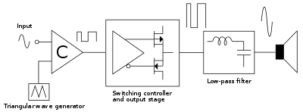](https://en.wikipedia.org/wiki/File:Pwm_amp.svg)

Block diagram of a basic switching or PWM (class-D) amplifier.

[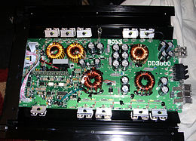](https://en.wikipedia.org/wiki/File:Inside_of_a_Boss_Audio_DD3600_Class_D_mono_block_amp.jpg)

[Boss Audio](https://en.wikipedia.org/wiki/Boss_Audio) class-D mono amplifier with a [low-pass filter](https://en.wikipedia.org/wiki/Low-pass_filter) for powering [subwoofers](https://en.wikipedia.org/wiki/Subwoofer)

Class-D amplifiers use some form of [pulse-width modulation](https://en.wikipedia.org/wiki/Pulse-width_modulation) to control the output devices. The conduction angle of each device is no longer related directly to the input signal but instead varies in pulse width.

In the [class-D amplifier](https://en.wikipedia.org/wiki/Class-D_amplifier) the active devices (transistors) function as electronic switches instead of linear gain devices; they are either on or off. The analog signal is converted to a stream of pulses that represents the signal by [pulse-width modulation](https://en.wikipedia.org/wiki/Pulse-width_modulation), [pulse-density modulation](https://en.wikipedia.org/wiki/Pulse-density_modulation), [delta-sigma modulation](https://en.wikipedia.org/wiki/Delta-sigma_modulation) or a related modulation technique before being applied to the amplifier. The time average power value of the pulses is directly proportional to the analog signal, so after amplification the signal can be converted back to an analog signal by a passive [low-pass filter](https://en.wikipedia.org/wiki/Low-pass_filter). The purpose of the output filter is to smooth the pulse stream to an analog signal, removing the high frequency spectral components of the pulses. The frequency of the output pulses is typically ten or more times the highest frequency in the input signal to amplify, so that the filter can adequately reduce the unwanted harmonics and accurately reproduce the input.[[19]](https://en.wikipedia.org/wiki/Power_amplifier_classes#cite_note-19)

The main advantage of a class-D amplifier is power efficiency. Because the output pulses have a fixed amplitude, the switching elements (usually [MOSFETs](https://en.wikipedia.org/wiki/MOSFET), but vacuum tubes, and at one time [bipolar transistors](https://en.wikipedia.org/wiki/Bipolar_transistor), were used) are switched either completely on or completely off, rather than operated in linear mode. A MOSFET operates with the lowest resistance when fully on and thus (excluding when fully off) has the lowest power dissipation when in that condition. Compared to an equivalent class-AB device, a class-D amplifier's lower losses permit the use of a smaller [heat sink](https://en.wikipedia.org/wiki/Heat_sink) for the MOSFETs while also reducing the amount of input power required, allowing for a lower-capacity power supply design. Therefore, class-D amplifiers are typically smaller than an equivalent class-AB amplifier.

Another advantage of the class-D amplifier is that it can operate from a digital signal source without requiring a [digital-to-analog converter](https://en.wikipedia.org/wiki/Digital-to-analog_converter) (DAC) to convert the signal to analog form first. If the signal source is in digital form, such as in a [digital media player](https://en.wikipedia.org/wiki/Digital_media_player) or [computer sound card](https://en.wikipedia.org/wiki/Computer_sound_card), the digital circuitry can convert the binary digital signal directly to a [pulse-width modulation](https://en.wikipedia.org/wiki/Pulse-width_modulation) signal that is applied to the amplifier, simplifying the circuitry considerably.

A class-D amplifier with moderate output power can be constructed using regular CMOS logic process, making it suitable for integration with other types of digital circuitry. Thus it is commonly found in [System-on-Chips](https://en.wikipedia.org/wiki/System-on-Chip) with integrated audio when the amplifier shares a die with the main processor or DSP.

Class-D amplifiers are widely used to control [motors](https://en.wikipedia.org/wiki/Electric_motor)—but are now also used as power amplifiers, with extra circuitry that converts analogue to a much higher frequency pulse width modulated signal. Switching power supplies have even been modified into crude class-D amplifiers (though typically these only reproduce low-frequencies with acceptable accuracy).

High quality class-D audio power amplifiers have now appeared on the market. These designs have been said to rival traditional AB amplifiers in terms of quality. An early use of class-D amplifiers was high-power [subwoofer](https://en.wikipedia.org/wiki/Subwoofer) amplifiers in cars. Because subwoofers are generally limited to a bandwidth of no higher than 150 Hz, switching speed for the amplifier does not have to be as high as for a full range amplifier, allowing simpler designs. Class-D amplifiers for driving subwoofers are relatively inexpensive in comparison to class-AB amplifiers.

The letter *D* used to designate this amplifier class is simply the next letter after *C* and, although occasionally used as such, does not stand for [*digital*](https://en.wikipedia.org/wiki/Digital_data). Class-D and class-E amplifiers are sometimes mistakenly described as "digital" because the output waveform superficially resembles a pulse-train of digital symbols, but a class-D amplifier merely converts an input waveform into a continuously [pulse-width modulated](https://en.wikipedia.org/wiki/Pulse-width_modulation) analog signal. (A digital waveform would be [pulse-code modulated](https://en.wikipedia.org/wiki/Pulse-code_modulated).)

### Additional classes

Other amplifier classes are mainly variations of the previous classes. For example, class-G and class-H amplifiers are marked by variation of the supply rails (in discrete steps or in a continuous fashion, respectively) following the input signal. Wasted heat on the output devices can be reduced as excess voltage is kept to a minimum. The amplifier that is fed with these rails itself can be of any class. These kinds of amplifiers are more complex, and are mainly used for specialized applications, such as very high-power units. Also, class-E and class-F amplifiers are commonly described in literature for radio-frequency applications where efficiency of the traditional classes is important, yet several aspects deviate substantially from their ideal values. These classes use harmonic tuning of their output networks to achieve higher efficiency and can be considered a subset of class C due to their conduction-angle characteristics.

#### Class E

The class-E amplifier is a highly efficient tuned switching power amplifier used at radio frequencies. It uses a single-pole switching element and a tuned reactive network between the switch and the load. The circuit obtains high efficiency by only operating the switching element at points of zero current (on to off switching) or zero voltage (off to on switching) which minimizes power lost in the switch, even when the switching time of the devices is long compared to the frequency of operation.[[20]](https://en.wikipedia.org/wiki/Power_amplifier_classes#cite_note-MA01-20)

The class-E amplifier is frequently cited to have been first reported in 1975.[[21]](https://en.wikipedia.org/wiki/Power_amplifier_classes#cite_note-21) However, a full description of class-E operation may be found in the 1964 doctoral thesis of Gerald D. Ewing.[[22]](https://en.wikipedia.org/wiki/Power_amplifier_classes#cite_note-22) Interestingly, analytical design-equations only recently became known.[[23]](https://en.wikipedia.org/wiki/Power_amplifier_classes#cite_note-23)

#### Class F

In push–pull amplifiers and in CMOS, the even harmonics of both transistors just cancel. Experiment shows that a square wave can be generated by those amplifiers. Theoretically square waves consist of odd harmonics only. In a class-D amplifier, the output filter blocks all harmonics; i.e., the harmonics see an open load. So even small currents in the harmonics suffice to generate a voltage square wave. The current is in phase with the voltage applied to the filter, but the voltage across the transistors is out of phase. Therefore, there is a minimal overlap between current through the transistors and voltage across the transistors. The sharper the edges, the lower the overlap.

While in class D, transistors and the load exist as two separate modules, class F admits imperfections like the parasitics of the transistor and tries to optimise the global system to have a high impedance at the harmonics.[[24]](https://en.wikipedia.org/wiki/Power_amplifier_classes#cite_note-24) Of course there must be a finite voltage across the transistor to push the current across the on-state resistance. Because the combined current through both transistors is mostly in the first harmonic, it looks like a sine. That means that in the middle of the square the maximum of current has to flow, so it may make sense to have a dip in the square or in other words to allow some overswing of the voltage square wave. A class-F load network by definition has to transmit below a cutoff frequency and reflect above.

Any frequency lying below the cutoff and having its second harmonic above the cutoff can be amplified, that is an octave bandwidth. On the other hand, an inductive-capacitive series circuit with a large inductance and a tunable capacitance may be simpler to implement. By reducing the duty cycle below 0.5, the output amplitude can be modulated. The voltage square waveform degrades, but any overheating is compensated by the lower overall power flowing. Any load mismatch behind the filter can only act on the first harmonic current waveform, clearly only a purely resistive load makes sense, then the lower the resistance, the higher the current.

Class F can be driven by sine or by a square wave, for a sine the input can be tuned by an inductor to increase gain. If class F is implemented with a single transistor, the filter is complicated to short the even harmonics. All previous designs use sharp edges to minimize the overlap.

#### Classes G and H

[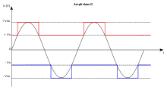](https://en.wikipedia.org/wiki/File:ClassG.svg)

Idealized class-G rail voltage modulation

[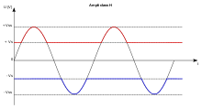](https://en.wikipedia.org/wiki/File:ClassH.svg)

Idealized class-H rail voltage modulation

There are a variety of amplifier designs that enhance class-AB output stages with more efficient techniques to achieve greater efficiency with low distortion. These designs are common in large audio amplifiers since the [heatsinks](https://en.wikipedia.org/wiki/Heatsink" \o "Heatsink) and power transformers would be prohibitively large (and costly) without the efficiency increases. The terms "class G" and "class H" are used interchangeably to refer to different designs, varying in definition from one manufacturer or paper to another.

Class-G amplifiers (which use "rail switching" to decrease power consumption and increase efficiency) are more efficient than class-AB amplifiers. These amplifiers provide several power rails at different voltages and switch between them as the signal output approaches each level. Thus, the amplifier increases efficiency by reducing the wasted power at the output transistors. Class-G amplifiers are more efficient than class AB but less efficient when compared to class D, however, they do not have the [electromagnetic interference](https://en.wikipedia.org/wiki/Electromagnetic_interference) effects of class D.

Class-H amplifiers create an infinitely variable (analog) supply rail. They are sometimes referred to as rail trackers. This is done by modulating the supply rails so that the rails are only a few volts larger than the output signal "tracking" it at any given time. The output stage operates at its maximum efficiency all the time. This is due to the circuit ability to keep the rail transistors (T2 and T4) in cutoff until a music voltage peak is of a sufficient magnitude to require the additional voltage from the + and - 80 V supplies. Refer to the schematic figure. The class H amplifier can actually be thought of as two amplifiers in series. In the schematic example shown by the figure, + - 40 V rail amplifiers can produce about 100 Watts continuous into an 8 ohm load. If vout music signal is operating below 40 volts, the amplifier only has the losses associated with a 100 W amplifier. This is because the Class H upper devices T2 and T4 are only used when the music signal is between 100 and 400 Watts output. The key to understanding this efficiency without churning the actual numbers is that we have a 400 Watt capable amplifier but with the efficiency of a 100 Watt amplifier. This is because the wave-forms of music contain long periods under 100 Watts and contain only brief bursts of up to 400 Watts instantaneous; in other words, the losses at 400 Watts are for brief time periods. If this example were drawn as a class AB with just the 80 V supplies in place of the 40 V supplies, the T1 and T3 transistors would need to be in conduction throughout the 0 V to 80 V signal with the corresponding VI losses all through the vout wave period - not just the brief high energy bursts. To achieve this rail tracking control, T2 and T4 act as current amplifiers, each in series with its low voltage counterpart T1 and T3. The purpose of T2 and T3 is to allow back-biasing diode D2 when vout is at a positive peak (above 39.3 V) and back biasing D4 when vout is at negative peak less than -39.3 V. During the vout musical peaks from 100 to 400 Watts, the 40 V supplies have zero *Amperes drawn from them* as all current comes from the 80 V rails. This figure is too simplistic however as It will not actually control the T2 T4 transistors at all. This is because the D1 and D3 diodes which are intended to provide a path for the vout back into the upper devices are *always reverse biased. They are drawn backwards.* In place of these diodes, a voltage amplifier with gain which uses vout as its input would be needed in an actual design. There is another reason for this gain requirement between vout and T2 base in an actual class H design and that is to assure that the signal applied to the T2 is always "ahead" of the Vout signal so it can never "catch up" with the rail tracker. The rail tracker amplifier might have a 50 V/µs slew rate while the AB amplifier might have only a 30 V/µs slew rate in order to guarantee this.

54. Define frequency distortion?

Ans: Distortion in which the relative magnitudes of the different frequency components of a wave are changed during transmission or amplification. Also known as amplitude distortion; amplitude-frequency distortion; waveform-amplitude distortion.

55. List the advantages and disadvantages of push pull class B amplifier.

Ans: **ADVANTAGES –**

**(i)**The circuit efficiency of a class-B push-pull amplifier is much higher than class-A amplifier.The reason for this is that no power is drawn from the D.C.power supply Vcc under no signal condition in class-B push-pull amplifier.

**(ii)**The use of push-pull system in the class-B amplifier eliminates even order harmonics in A.C. output signal.

**(iii)** For a given amount distortion  the circuit provides more output per device because of the absence of even harmonics.

**(iv)** There is no D.C. component in the output signal.It is because of the fact,that D.C. components of two collector currents,through the two halves of primary of the output transformer flow in opposite directions.As a result,there is no possibility of core saturation of the output transformer, even at the peak value of the signals.Thus,we can use smaller sized cores in the transformers,without affecting the circuit performances.

**DISADVANTAGES-**

**(i)** Harmonic distortion is high.

**(ii)** Self-bias is not used.

56. Define rectifiers?

Ans: rectifier, **device that converts alternating electric current into direct current**. ... Rectification, or conversion of alternating current (AC) to direct current (DC), is mentioned in the... Diodes are used in half- and full-wave circuits. In a full-wave circuit, two diodes are used, one for each for half of the cycle.

57. Write down the important characteristics of a rectifier circuit?

Ans:  rectifier is a circuit which **converts the Alternating Current (AC) input power into a Direct Current (DC) output power**. A half-wave rectifier is a circuit that allows only one half-cycle of the AC voltage waveform to be applied to the load, resulting in one non-alternating polarity across it

58. Define half wave rectifier?

Ans:

Half Wave Rectifier Circuit

A half-wave rectifier is the simplest form of the rectifier and requires only one diode for the construction of a halfwave rectifier circuit.

A halfwave rectifier circuit consists of three main components as follows:

* A diode
* A transformer
* A resistive load

**Given below is the half-wave rectifier diagram:**

**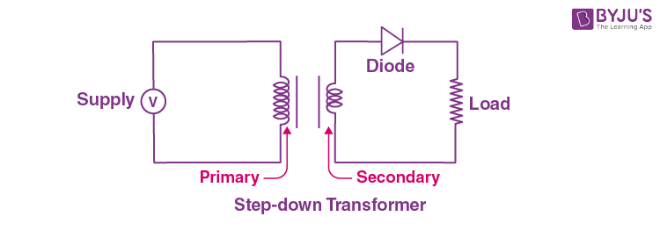**

59. Define transformer utilization factor

Ans: The **transformer utilization factor (TUF)** of a [rectifier](https://en.wikipedia.org/wiki/Rectifier) circuit is defined as the ratio of the DC power available at the load resistor to the AC rating of the secondary coil of a [transformer](https://en.wikipedia.org/wiki/Transformer).[[1]](https://en.wikipedia.org/wiki/Transformer_utilization_factor#cite_note-Rashid2011-1)[[2]](https://en.wikipedia.org/wiki/Transformer_utilization_factor#cite_note-A.P.Godse2008-2)

{\displaystyle T.U.F={\frac {P\_{odc}}{V\_{A}\ rating\ of\ transformer}}}

60. Write down the uses of bridge rectifier circuit?

Ans: A bridge rectifier **converts mains AC input to DC output**. In power supplies, bridge rectifiers are used to provide necessary DC voltages for electronic components or devices.

61. Define voltage regulation

Ans: **voltage regulation** is a measure of change in the [voltage](https://en.wikipedia.org/wiki/Voltage) magnitude between the sending and receiving end of a component, such as a [transmission](https://en.wikipedia.org/wiki/Transmission_line) or distribution line. Voltage regulation describes the ability of a system to provide near constant voltage over a wide range of [load](https://en.wikipedia.org/wiki/Electrical_load) conditions. The term may refer to a passive property that results in more or less voltage drop under various load conditions, or to the active intervention with devices for the specific purpose of adjusting voltage.

62. What is a bleeder resistor?

Ans: A **bleeder resistor** is a [resistor](https://en.wikipedia.org/wiki/Resistor) connected in [parallel](https://en.wikipedia.org/wiki/Series_and_parallel_circuits#Parallel_circuits) with the output of a high-voltage [power supply](https://en.wikipedia.org/wiki/Power_supply) circuit for the purpose of discharging the electric charge stored in the power supply's [filter capacitors](https://en.wikipedia.org/wiki/Filter_capacitor) when the equipment is turned off, for safety reasons. It eliminates the possibility of a leftover charge causing [electric shock](https://en.wikipedia.org/wiki/Electric_shock) if people handle or service the equipment in the off state, believing it is safe. A bleeder resistor is usually a standard resistor rather than a specialized component.

64. Write down the various performance parameters of power supplies?

* Ans: Input Voltage Range. The input voltage range determines the maximum and minimum allowable input supply for the LDO. ...
* Output Voltage Range. The output voltage of an LDO may be fixed or programmable. ...
* Dropout Voltage. ...
* Maximum Output Current. ...
* Output Voltage Accuracy.

65. Define voltage multipliers

Ans: A **voltage multiplier** is an [electrical circuit](https://en.wikipedia.org/wiki/Electrical_circuit) that converts AC electrical power from a lower [voltage](https://en.wikipedia.org/wiki/Voltage) to a higher DC voltage, typically using a network of [capacitors](https://en.wikipedia.org/wiki/Capacitor) and [diodes](https://en.wikipedia.org/wiki/Diode).

Voltage multipliers can be used to generate a few volts for electronic appliances, to millions of volts for purposes such as high-energy physics experiments and lightning safety testing. The most common type of voltage multiplier is the half-wave series multiplier, also called the Villard cascade .